Go to the MyOn website: [www.myon.co.uk](http://www.myon.co.uk) and click login. Use the username and password given to you by your teacher.

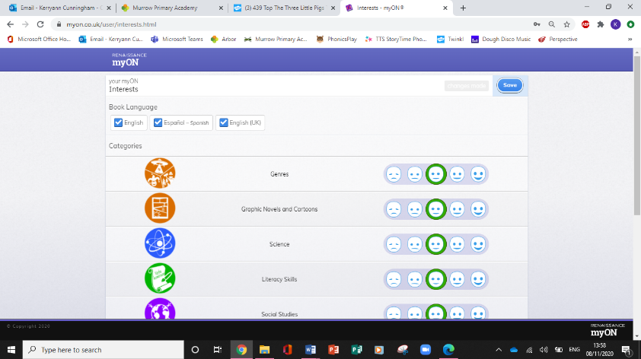The first page you will see after logging on for the first time will be this one. Here is where you can select your interests so that the MyOn system can recommend specific book which might be of interest to you as a reader. You will only need to do this once. When you have selected your preferences, click save at the top.

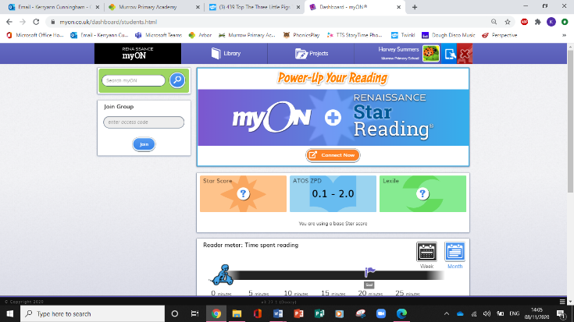After saving, you will automatically be redirected to your homepage. This page is individualised to you as a reader. Your engagement with MyOn will be reflected on this page.

MyOn automatically sets a reading level for you based on your school year group.

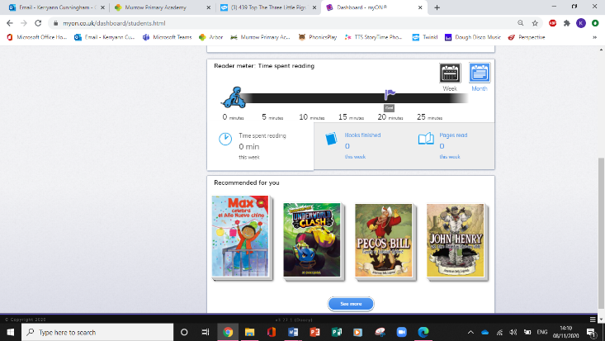When you scroll down your homepage, you will see the ‘Reader Meter’. This shows you how you are progressing with your reading.

Beneath that is the recommendations for you, based on the interest levels you entered when you logged on for the first time.

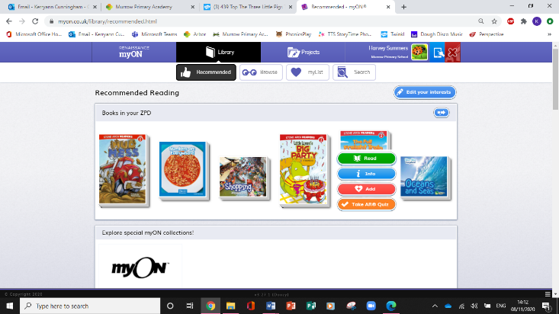To start reading, hover over a book cover of your choice, and click read. You will be taken to the book and you can click ‘Start the Book’.

Within the book screen, there are lots of functions available to you to support you with your reading.

You can exit the book at any time as well as when you have finished reading. To return to your homepage, click the ‘Exit’ button

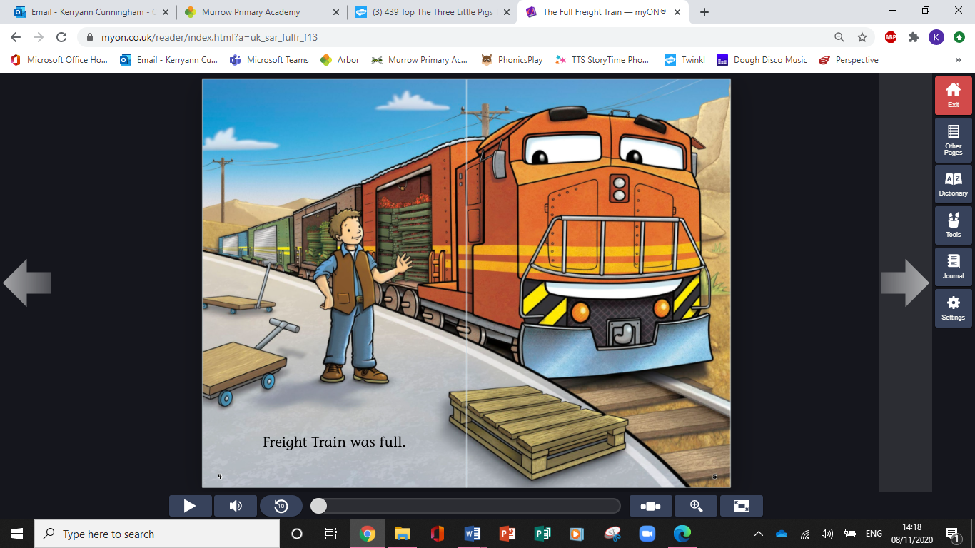

Use this button to change the volume of the audio text.

This button makes your book go into full-screen mode.

If you need to zoom in to be able to see clearer, click this button.

You are able to browse the pages of the book using this button.

This button will read aloud the text on the page for you to listen to.

Use the arrows to turn the pages. You can move back as well as forwards throughout the text.

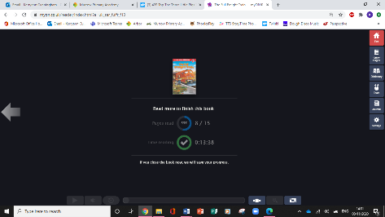When you have finished reading your book, a summary of your reading session will appear. If you have skipped pages, you will need to go back and read them to complete the book and get 100%.

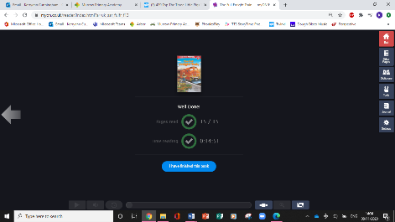

When you have read it all, you will have the option to click’ I have finished this book’.

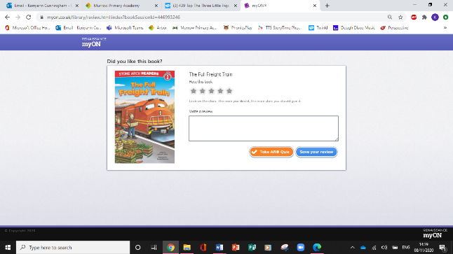After reading your book, you will be asked to give it a star-rating and have the option to write a review if you wish to.

*In Reception and Key Stage 1, we do not take AR Quizzes, so please don’t click this button!*

Click ‘Save Review’ and you will be redirected back to your book recommendations page. Here you can choose another book to read.

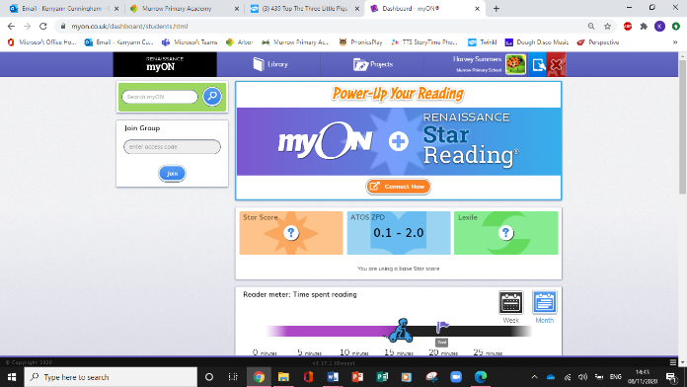You can return to your homepage at anytime by clicking the ‘Renaissacne MyOn’ button.

You will see that your homepage has automatically updated to reflect your most recent reading. Your teacher can also see all of this information.

**Keep reading to keep progressing!!**

***Miss Cunningham’s MyOn Top-Tips!***

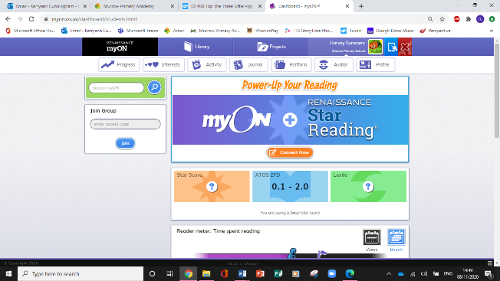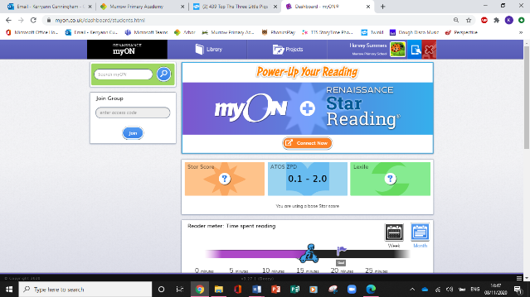

Click this symbol to get a secret pin which will allow you to use MyOn on a tablet.

Click on your name to see different options for you. Here your can see your progress, change your interests, check your reading activity (similar to the Reader Meter), look at your personal reading portfolio, change your avatar and see your reading achievements in the profile tab.

* Make sure your are reading books aloud to an adult as well as listening to them using the audio play button. This will help you to continue to practise and develop your phonic knowledge and sight-vocabulary, as well as improve your reading skills and abililty.
* Be sure to read all of the book you have chosen.
* Leave reviews about the books you have read. These can influence other readers too!